SQL Queries

1. SELECT Movie_title FROM Movies, Cinemas, Screening, City WHERE City.City_ID =

Cinemas.City_ID AND Cinemas.Cinema_ID = Screening.Cinema_ID AND Screening.Movie_ID =

Movies.Movie_ID AND City.City_Name = “Dallas”;

1. SELECT DISTINCT Cinema_Name FROM Cinemas, Screening, Movies Cinemas.Cinema_ID = Screening.Cinema_ID AND Movies.Movie_ID = Screening.Movie_ID AND Movies.Movie_title = “Gladiator”;

1. SELECT Cinema_Name, SeatNum From Booking, Cinemas,Movies WHERE Booking.Cinema_ID = Cinemas.Cinema_ID AND Booking.Movie_ID = Movies.Movie_ID AND Movies.Movie_title = “Gladiator”;

1. SELECT Cinema_Name, Movie_title, Screen_Time FROM (Cinemas NATURAL JOIN Screening NATURAL JOIN Movies) Where Cinema_Name = “Crowd Cinema” AND Movie_title = “Gladiator”;

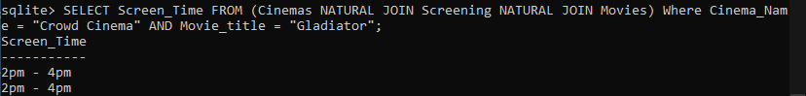

1. SELECT Movie_title FROM (Movies NATURAL JOIN Screening) WHERE Screen_Time = “2pm - 4pm”;

1. SELECT Cinema_Name, Movie_title, Screen_Time, SeatNum FROM (Booking NATURAL JOIN Screening NATURAL JOIN Cinemas NATURAL JOIN Movies) Where BT_ID = 21;

1. SELECT Movie_title, Screen_Time, City_Name, Cinema_Name FROM (Screening NATURAL JOIN Movies NATURAL JOIN Cinemas NATURAL JOIN City);

1. SELECT Movie_title,SeatNum FROM (Booking NATURAL JOIN Screening NATURAL JOIN Cinemas NATURAL JOIN Movies) WHERE Cinema_Name = “Crowd Cinema”; Text

   Description automatically generated